**\*\*\*\*\*\*\*\*\*\*\*\*\*\*\*\*\*\*\*\*\*\*\*\*\*\*\*\*\*\*\*\*\*\*\*\*\*\*\*\*\*\*\*\*\*\*\*\*\*\*\*\*\*\*\*\*\*\*\*\*\*\*\*\*\*\*\*\*\*\*\*\*\*\*\***

# Assignment No. 01

**Name of Student:** Rupesh Ramesh Desai **Roll No.:**

**Class:** B.Sc III  **Date: / /**

**Signature:**

**\*\*\*\*\*\*\*\*\*\*\*\*\*\*\*\*\*\*\*\*\*\*\*\*\*\*\*\*\*\*\*\*\*\*\*\*\*\*\*\*\*\*\*\*\*\*\*\*\*\*\*\*\*\*\*\*\*\*\*\*\*\*\*\*\*\*\*\*\*\*\*\*\*\*\* Q. Program on Swing Program:**

import javax.swing.*; public class Swing

{

public static void main(String args[])

{

JFrame f=new JFrame();

JButton b=new JButton("Click Me"); b.setBounds(140,100,100,40);

f.add(b);

f.setSize(400,500);

f.setLayout(null);

f.setVisible(true);

}

}

**\*\*\*\*\*\*\*\*\*\*\*\*\*\*\*\*\*\*\*\*\*\*\*\*\*\*\*\*\*\*\*\*\*OUTPUT\*\*\*\*\*\*\*\*\*\*\*\*\*\*\*\*\*\*\*\*\*\*\*\*\*\*\*\*\*\*\*\*\***

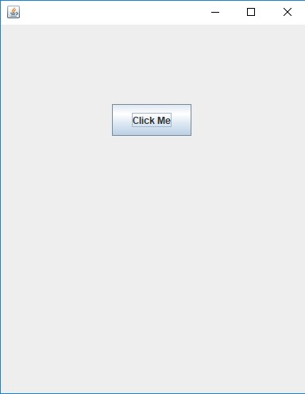

**\*\*\*\*\*\*\*\*\*\*\*\*\*\*\*\*\*\*\*\*\*\*\*\*\*\*\*\*\*\*\*\*\*\*\*\*\*\*\*\*\*\*\*\*\*\*\*\*\*\*\*\*\*\*\*\*\*\*\*\*\*\*\*\*\*\*\*\*\*\*\*\*\*\*\***

**\*\*\*\*\*\*\*\*\*\*\*\*\*\*\*\*\*\*\*\*\*\*\*\*\*\*\*\*\*\*\*\*\*\*\*\*\*\*\*\*\*\*\*\*\*\*\*\*\*\*\*\*\*\*\*\*\*\*\*\*\*\*\*\*\*\*\*\*\*\*\*\*\*\*\***

# Assignment No. 02

**Name of Student:** Rupesh Ramesh Desai **Roll No.:**

**Class:** B.Sc III **Date: / /**

**Signature:**

***************************************************************************

**Q. Simple program using servlet.**

**Program:**

**index.html:**

<!DOCTYPE html>

<html>

<head>

<title>TODO supply a title</title>

<meta charset="UTF-8">

<meta name="viewport" content="width=device-width, initial-scale=1.0"> </head>

<body>

<form action ="Assignment2">

<input type="submit" value="CLICK">

</form>

</body>

</html>

**\*\*\*\*\*\*\*\*\*\*\*\*\*\*\*\*\*\*\*\*\*\*\*\*\*\*\*\*\*\*\*\*\*OUTPUT\*\*\*\*\*\*\*\*\*\*\*\*\*\*\*\*\*\*\*\*\*\*\*\*\*\*\*\*\*\*\*\*\***

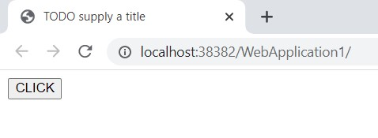

**Servlet:**

import java.io.IOException;

import java.io.PrintWriter;

import javax.servlet.ServletException;

import javax.servlet.http.HttpServlet;

import javax.servlet.http.HttpServletRequest;

import javax.servlet.http.HttpServletResponse;

public class Assignment2 extends HttpServlet {

protected void processRequest(HttpServletRequest request, HttpServletResponse response)

throws ServletException, IOException {

response.setContentType("text/html;charset=UTF-8");

try (PrintWriter out = response.getWriter()) {

out.println("<!DOCTYPE html>");

out.println("<html>");

out.println("<head>");

out.println("<title>Servlet Assignment2</title>");

out.println("</head>");

out.println("<body>");

out.println("<h1>Servlet Assignment2 at " + request.getContextPath() + "</h1>");

out.println("</body>");

out.println("</html>");

}

}

@Override

protected void doGet(HttpServletRequest request, HttpServletResponse response)

throws ServletException, IOException {

processRequest(request, response);

}

@Override

protected void doPost(HttpServletRequest request, HttpServletResponse response)

throws ServletException, IOException {

processRequest(request, response);

}

@Override

public String getServletInfo() {

return "Short description";

}

}

*********************************OUTPUT*********************************

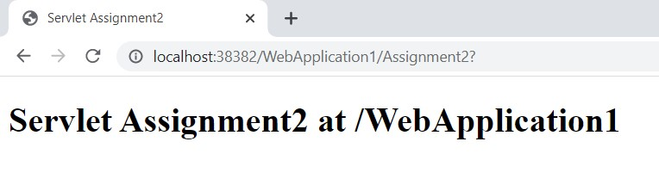

**\*\*\*\*\*\*\*\*\*\*\*\*\*\*\*\*\*\*\*\*\*\*\*\*\*\*\*\*\*\*\*\*\*\*\*\*\*\*\*\*\*\*\*\*\*\*\*\*\*\*\*\*\*\*\*\*\*\*\*\*\*\*\*\*\*\*\*\*\*\*\*\*\*\*\***

**\*\*\*\*\*\*\*\*\*\*\*\*\*\*\*\*\*\*\*\*\*\*\*\*\*\*\*\*\*\*\*\*\*\*\*\*\*\*\*\*\*\*\*\*\*\*\*\*\*\*\*\*\*\*\*\*\*\*\*\*\*\*\*\*\*\*\*\*\*\*\*\*\*\*\***

# Assignment No. 03

**Name of Student:** Rupesh Ramesh Desai **Roll No.:**

**Class:** B.Sc III **Date: / /**

**Signature:**

**\*\*\*\*\*\*\*\*\*\*\*\*\*\*\*\*\*\*\*\*\*\*\*\*\*\*\*\*\*\*\*\*\*\*\*\*\*\*\*\*\*\*\*\*\*\*\*\*\*\*\*\*\*\*\*\*\*\*\*\*\*\*\*\*\*\*\*\*\*\*\*\*\*\*\***

**Q. Simple program using JSP.**

**Program:**

**index.html:**

<html>

<head>

<title>TODO supply a title</title>

<meta charset="UTF-8">

<meta name="viewport" content="width=device-width, initial-scale=1.0"> </head>

<body>

<form action ="newjsp.jsp">

<input type="submit" value="CLICK">

</form>

</body>

</html>

*********************************OUTPUT*********************************

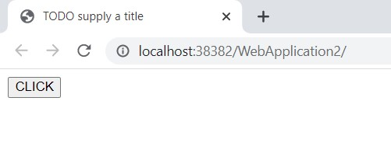

**Jsp:**

<%@page contentType="text/html" pageEncoding="UTF-8"%>

<!DOCTYPE html>

<html>

<head>

<meta http-equiv="Content-Type" content="text/html; charset=UTF-8">

<title>JSP Page</title>

</head>

<body>

<h1>Hello</h1>

</body>

</html>

*********************************OUTPUT*********************************

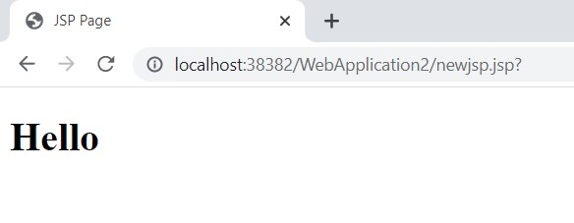

**\*\*\*\*\*\*\*\*\*\*\*\*\*\*\*\*\*\*\*\*\*\*\*\*\*\*\*\*\*\*\*\*\*\*\*\*\*\*\*\*\*\*\*\*\*\*\*\*\*\*\*\*\*\*\*\*\*\*\*\*\*\*\*\*\*\*\*\*\*\*\*\*\*\*\***

# Assignment No. 04

**Name of Student:** Rupesh Ramesh Desai **Roll No.:**

**Class:** B.Sc III **Date: / /**

**Signature:**

**\*\*\*\*\*\*\*\*\*\*\*\*\*\*\*\*\*\*\*\*\*\*\*\*\*\*\*\*\*\*\*\*\*\*\*\*\*\*\*\*\*\*\*\*\*\*\*\*\*\*\*\*\*\*\*\*\*\*\*\*\*\*\*\*\*\*\*\*\*\*\*\*\*\*\***

**Q. Program on Database Connection.**

**Program:**

import java.io.*;

import java.sql.*;

public class demo {

public static void main (String[] args) throws Exception

{

// class.forName("com.mysql.jdbc.Driver");

Connection con =DriverManager.getConnection("jdbc:mysql://localhost:3306/sandesh","root","root");

Statement stmt = con.createStatement();

ResultSet rs=stmt.executeQuery("select * from stud");

while(rs.next())

{

int sid = rs.getInt("sid");

String name = rs.getString("name");

System.out.println(sid+" "+name);

}

con.close();

}

}

**\*\*\*\*\*\*\*\*\*\*\*\*\*\*\*\*\*\*\*\*\*\*\*\*\*\*\*\*\*\*\*\*\*OUTPUT\*\*\*\*\*\*\*\*\*\*\*\*\*\*\*\*\*\*\*\*\*\*\*\*\*\*\*\*\*\*\*\*\***

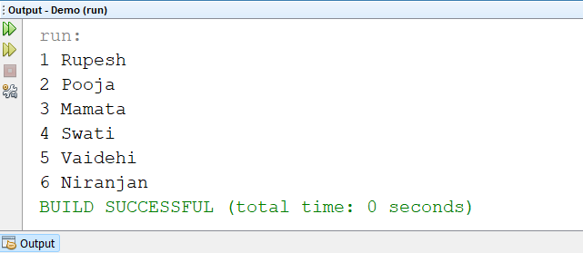

**\*\*\*\*\*\*\*\*\*\*\*\*\*\*\*\*\*\*\*\*\*\*\*\*\*\*\*\*\*\*\*\*\*\*\*\*\*\*\*\*\*\*\*\*\*\*\*\*\*\*\*\*\*\*\*\*\*\*\*\*\*\*\*\*\*\*\*\*\*\*\*\*\*\*\***

**\*\*\*\*\*\*\*\*\*\*\*\*\*\*\*\*\*\*\*\*\*\*\*\*\*\*\*\*\*\*\*\*\*\*\*\*\*\*\*\*\*\*\*\*\*\*\*\*\*\*\*\*\*\*\*\*\*\*\*\*\*\*\*\*\*\*\*\*\*\*\*\*\*\*\***

# Assignment No. 05

**Name of Student:** Rupesh Ramesh Desai **Roll No.:**

**Class:** B.Sc III **Date: / /**

**Signature:**

**\*\*\*\*\*\*\*\*\*\*\*\*\*\*\*\*\*\*\*\*\*\*\*\*\*\*\*\*\*\*\*\*\*\*\*\*\*\*\*\*\*\*\*\*\*\*\*\*\*\*\*\*\*\*\*\*\*\*\*\*\*\*\*\*\*\*\*\*\*\*\*\*\*\*\***

**Q. Develop a java application to store image in a database as well as retrieve image from database.**

**Program:**

**DataAccess.java**

package Pooja;

import java.sql.*;

import com.mysql.jdbc.Driver;

import java.sql.Connection;

import java.sql.SQLException;

import java.sql.Statement;

import java.sql.DriverManager;

import java.sql.ResultSet;

class DataAccess {

public static final String url1 = "jdbc:mysql://localhost:3306/Pooja";

public static final String USER = "root";

public static final String PASS = "root";

public static Connection getConnection() throws SQLException

{

try {

DriverManager.registerDriver(new Driver());

return DriverManager.getConnection(url1, USER, PASS);

} catch (Exception ex)

{

System.out.println(ex);

}

return null;

}

}

**Program:**

**Image1.java**

import static java.lang.System.out;

import java.sql.Connection;

import java.sql.PreparedStatement;

import java.sql.ResultSet;

import java.sql.SQLException;

import java.sql.Statement;

public class Image

{

private int Id;

private String Image;

public int getId() {

return Id;

}

public String getImage() {

return Image;

}

public void setImage(String Image) {

this.Image = Image;

}

public ResultSet getimage(int id) throws SQLException {

Connection con = DataAccess.getConnection();

try {

Statement stmt = con.createStatement();

ResultSet rs = stmt.executeQuery("SELECT * FROM image WHERE Id=" + id);

if (rs.next()) {

return rs;

}

} catch (SQLException ex) {

System.out.print(ex.toString());

}

return null;

}

public boolean insertimage(Image d) throws SQLException {

Connection cn = DataAccess.getConnection();

PreparedStatement ps = cn.prepareStatement("INSERT INTO image(Image) VALUES (?)");

ps.setString(1, d.getImage());

int i = ps.executeUpdate();

if (i == 1) {

return true;

}

return false;

}

}

**Program:**

**Image1.jsp**

<%@page contentType="text/html" pageEncoding="UTF-8"%>

<%@ page import="Pooja.Image1"%>

<%@ page import="com.mysql.jdbc.Driver" %>

<%@ page import="java.sql.Connection" %>

<%@ page import="java.sql.SQLException" %>

<%@ page import="java.sql.Statement" %>

<%@ page import="java.sql.DriverManager" %>

<%@ page import="java.sql.ResultSet" %>

<%! Image1 cm = new Image1();%>

<%! ResultSet rs,rs1;%>

<%! int num ,id;

String image=" ";

%>

<%!

void getMaxtid() {

try {

rs = cm.getMaxid();

num = rs.getInt(1);

} catch (Exception ex) {

}

}

%>

<%

if (request.getParameter("btnSave") != null) {

cm.setId(Integer.parseInt(request.getParameter("txtid")));

cm.setImage(request.getParameter("txtimage"));

cm.insertimage(cm);

out.print("<script>");

out.print("alert('insert record successfully')");

out.print("</script>");

getMaxtid();

}

%>

<html>

<head>

<meta http-equiv="Content-Type" content="text/html; charset=UTF-8">

<link href="UL/css/bootstrap.css" rel="stylesheet" type="text/css"/>

<script src="UL/jquery-3.6.0.min.js" type="text/javascript"></script>

<script src="UL/js/bootstrap.js" type="text/javascript"></script>

<title>JSP Page</title>

</head>

<body>

<img src="Img/Student.jpg" alt=""/>

<img src="Img/Study.jpg" alt=""/>

<img src="Img/Study1.jpg" alt=""/>

<img src="Img/Study3.jpg" alt=""/>

<img src="Img/Lapto.jpg" alt=""/>

<img src="Img/lp3.jpg" alt=""/>

<img src="Img/laptop1.jpg" alt=""/>

<form method="post" name="frmclass">

<div class="container">

<div class="col-md-12">

<div class="panel panel-primary">

<div class="panel-heading"> <h3> Image Information </h3></div>

<div class="panel-body">

<div class="row">

<div class="col-md-2">

<label> Id</label>

<input type="text" id="txtid" Name="txtid" value="<%=num%>" class="form-control">

</div>

<div class="col-md-3">

<label> Image</label>

<input type="text" id="txtimage" Name="txtimage" value="<%=image%>" class="form-control">

</div>

</div>

<div class="row"><br>

<div class="col-md-12 btn-group">

<input type="submit" value="Save" name="btnSave" id="btnSave" class="btn btn-success">

<input type="submit" value="Update" name="btnUpdate" id="btnUpdate" class="btn btn-primary">

<input type="submit" value="Delete" name="btnDelete" id="btnDelete" class="btn btn-danger">

<input type="submit" value="Cancel" name="btnCancle" id="btnCancle" class="btn btn-warning">

</div>

</div>

</div>

</div>

</div>

</form>

</body>

</html>

**\*\*\*\*\*\*\*\*\*\*\*\*\*\*\*\*\*\*\*\*\*\*\*\*\*\*\*\*\*\*\*\*\*OUTPUT\*\*\*\*\*\*\*\*\*\*\*\*\*\*\*\*\*\*\*\*\*\*\*\*\*\*\*\*\*\*\*\*\***

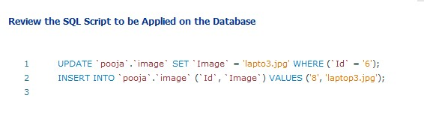

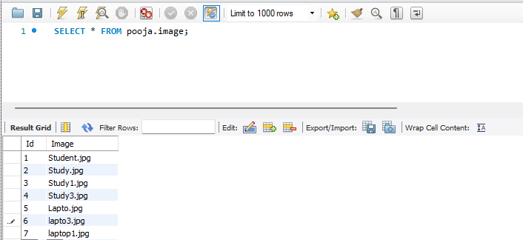

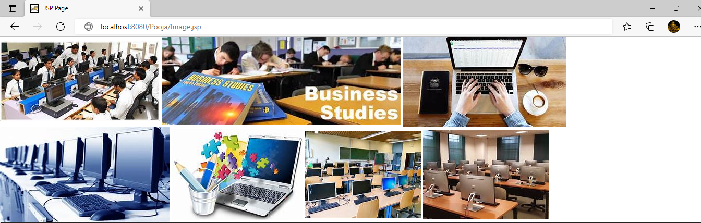

**\*\*\*\*\*\*\*\*\*\*\*\*\*\*\*\*\*\*\*\*\*\*\*\*\*\*\*\*\*\*\*\*\*\*\*\*\*\*\*\*\*\*\*\*\*\*\*\*\*\*\*\*\*\*\*\*\*\*\*\*\*\*\*\*\*\*\*\*\*\*\*\*\*\*\***

# Assignment No. 06

**Name of Student:** Rupesh Ramesh Desai **Roll No.:**

**Class:** B.Sc III **Date: / /**

**Signature:**

**\*\*\*\*\*\*\*\*\*\*\*\*\*\*\*\*\*\*\*\*\*\*\*\*\*\*\*\*\*\*\*\*\*\*\*\*\*\*\*\*\*\*\*\*\*\*\*\*\*\*\*\*\*\*\*\*\*\*\*\*\*\*\*\*\*\*\*\*\*\*\*\*\*\*\***

**Q. Create EMP table in database and perform insert, update and delete operation on EMP table using JSP.**

**Program:**

**DataAccess.java**

package Pooja;

import java.sql.*;

import com.mysql.jdbc.Driver;

import java.sql.Connection;

import java.sql.SQLException;

import java.sql.Statement;

import java.sql.DriverManager;

import java.sql.ResultSet;

class DataAccess {

public static final String url1 = "jdbc:mysql://localhost:3306/ems";

public static final String USER = "root";

public static final String PASS = "root";

public static Connection getConnection() throws SQLException

{

try {

DriverManager.registerDriver(new Driver());

return DriverManager.getConnection(url1, USER, PASS);

} catch (Exception ex)

{

System.out.println(ex);

}

return null;

}

}

**Program:**

**EmpMaster.java**

package Pooja;

import static java.lang.System.out;

import java.sql.Connection;

import java.sql.Date;

import java.sql.PreparedStatement;

import java.sql.ResultSet;

import java.sql.SQLException;

import java.sql.Statement;

public class EmpMaster

{

private int EmpId;

private String EmpName;

private int EmpCode;

private String MobileNo;

private String Email;

private String BasicSalary;

public int getEmpId() {

return EmpId;

}

public void setEmpId(int EmpId) {

this.EmpId = EmpId;

}

public String getEmpName() {

return EmpName;

}

public void setEmpName(String EmpName) {

this.EmpName = EmpName;

}

public int getEmpCode() {

return EmpCode;

}

public void setEmpCode(int EmpCode) {

this.EmpCode = EmpCode;

}

public String getMobileNo() {

return MobileNo;

}

public void setMobileNo(String MobileNo) {

this.MobileNo = MobileNo;

}

public String getEmail() {

return Email;

}

public void setEmail(String Email) {

this.Email = Email;

}

public String getBasicSalary() {

return BasicSalary;

}

public void setBasicSalary(String BasicSalary) {

this.BasicSalary = BasicSalary;

}

public ResultSet getempmaster(int id) throws SQLException {

Connection con = DataAccess.getConnection();

try {

Statement stmt = con.createStatement();

ResultSet rs = stmt.executeQuery("SELECT * FROM empmaster WHERE EmpId=" + id);

if (rs.next()) {

return rs;

}

} catch (SQLException ex) {

System.out.print(ex.toString());

}

return null;

}

public ResultSet getempmaster() throws SQLException {

Connection con = DataAccess.getConnection();

try {

Statement stmt = con.createStatement();

ResultSet rs = stmt.executeQuery("SELECT * FROM empmaster");

if (rs.next()) {

return rs;

}

} catch (SQLException ex) {

System.out.print(ex.toString());

}

return null;

}

public ResultSet getMaxid() throws SQLException {

Connection con = DataAccess.getConnection();

try {

Statement stmt = con.createStatement();

ResultSet rs = stmt.executeQuery("select ifnull(max(EmpId+1),1) as maxcode from empmaster");

if (rs.next()) {

return rs;

}

} catch (SQLException ex) {

}

return null;

}

public boolean insertempmaster(EmpMaster d) throws SQLException {

Connection cn = DataAccess.getConnection();

PreparedStatement ps = cn.prepareStatement("INSERT INTO empmaster (EmpName,EmpCode,MobileNo,Email,BasicSalary) VALUES (?,?,?,?,?)");

ps.setString(1, d.getEmpName());

ps.setInt(2, d.getEmpCode());

ps.setString(3, d.getMobileNo());

ps.setString(4, d.getEmail());

ps.setString(5,d.getBasicSalary());

int i = ps.executeUpdate();

if (i == 1) {

return true;

}

return false;

}

public boolean updateempmaster(EmpMaster d) throws SQLException {

Connection con = DataAccess.getConnection();

try {

PreparedStatement ps = con.prepareStatement("update empmaster SET EmpName=?,EmpCode=?,MobileNo=?,Email=?,BasicSalary=? where EmpId=?");

ps.setString(1, d.getEmpName());

ps.setInt(2, d.getEmpCode());

ps.setString(3, d.getMobileNo());

ps.setString(4, d.getEmail());

ps.setString(5,d.getBasicSalary());

int i = ps.executeUpdate();

if (i == 1) {

return true;

}

} catch (SQLException ex) {

ex.printStackTrace();

}

return false;

} public boolean deleteTest(int id) throws SQLException {

Connection con = DataAccess.getConnection();

try {

Statement stmt = con.createStatement();

int i = stmt.executeUpdate("delete * from empmaster where EmpId=" + id);

if (i == 1) {

return true;

}

} catch (SQLException ex) {

}

return false;

} public ResultSet getTestAll() throws SQLException {

Connection con = DataAccess.getConnection();

try {

Statement stmt = con.createStatement();

ResultSet rs = stmt.executeQuery("SELECT * FROM empmaster ");

if (rs.next()) {

while (rs.next()) {

return rs;

}

}

} catch (SQLException ex) {

out.print(ex.toString());

}

return null;

}

}

**Program:**

**EmpMaster.jsp**

<%@page contentType="text/html" pageEncoding="UTF-8"%>

<%@ page import="Pooja.EmpMaster"%>

<%@ page import="com.mysql.jdbc.Driver" %>

<%@ page import="java.sql.Connection" %>

<%@ page import="java.sql.SQLException" %>

<%@ page import="java.sql.Statement" %>

<%@ page import="java.sql.DriverManager" %>

<%@ page import="java.sql.ResultSet" %>

<%! EmpMaster cm = new EmpMaster();%>

<%! ResultSet rs,rs1;%>

<%! int num, empId;

String empname=" ";

int empcode;

String mobileno=" ";

String email=" ";

String basicsalary="";

%>

<%! void getMaxtid() {

try {

rs = cm.getMaxid();

num = rs.getInt(1);

} catch (Exception ex) {

}

}

%>

<%

if (request.getParameter("btnSave") != null) {

cm.setEmpName(request.getParameter("txtempname"));

cm.setEmpCode(Integer.parseInt(request.getParameter("txtempcode")));

cm.setMobileNo(request.getParameter("txtmobileno"));

cm.setEmail(request.getParameter("txtmailid"));

cm.setBasicSalary(request.getParameter("txtsalary"));

cm.insertempmaster(cm);

out.print("<script>");

out.print("alert('insert record successfully')");

out.print("</script>");

getMaxtid();

}

if (request.getParameter("btnUpdate")!= null) {

cm.setEmpName(request.getParameter("txtempname"));

cm.setEmpCode(Integer.parseInt(request.getParameter("txtempcode")));

cm.setMobileNo(request.getParameter("txtmobileno"));

cm.setEmail(request.getParameter("txtmailid"));

cm.setBasicSalary(request.getParameter("txtsalary"));

cm.updateempmaster(cm);

out.print("<script>");

out.print("alert('update record successfully')");

out.print("</script>");

getMaxtid();

}

if (request.getParameter("edit") != null) {

try {

int eid = Integer.parseInt(request.getParameter("edit"));

ResultSet rs1=cm.getempmaster(eid);

num = rs1.getInt(1);

empname = rs1.getString(2);

empcode=rs1.getInt(3);

mobileno=rs1.getString(4);

email=rs1.getString(5);

basicsalary=rs1.getString(6);

} catch (Exception ex) {

out.println(ex);

}

}

if (request.getParameter("delete") != null) {

try {

int id = Integer.parseInt(request.getParameter("delete"));

out.print("<script>");

out.print("alert('Delete record successfully')");

out.print("</script>");

cm.deleteTest(id);

} catch (Exception ex) {

out.println(ex);

}

}

%>

<html>

<head>

<meta http-equiv="Content-Type" content="text/html; charset=UTF-8">

<link href="UL/css/bootstrap.css" rel="stylesheet" type="text/css"/>

<script src="UL/jquery-3.6.0.min.js" type="text/javascript"></script>

<script src="UL/js/bootstrap.js" type="text/javascript"></script>

<title>JSP Page</title>

</head>

<body>

<form method="post" name="frmclass">

<div class="container">

<div class="col-md-12">

<div class="panel panel-primary">

<div class="panel-heading"> <h3> Employee Master </h3></div>

<div class="panel-body">

<div class="row">

<div class="col-md-2">

<label> Id </label>

<input type="text" id="txtid" Name="txtid" value="<%=num%>" class="form-control">

</div>

<div class="col-md-3">

<label> Name</label>

<input type="text" id="txtempname" Name="txtempname" value="<%=empname%>" class="form-control">

</div>

</div>

<div class="row">

<div class="col-md-3">

<label> Code</label>

<input type="text" id="txtempcode" Name="txtempcode" value="<%=empcode%>"class="form-control">

</div>

<div class="col-md-3">

<label>Mobile No</label>

<input type="text" id="txtmobileno" Name="txtmobileno" value="<%=mobileno%>"class="fo </div>

</div>

<div class="row">

<div class="col-md-3">

<label>Email</label>

<input type="text" id="txtmailid" Name="txtmailid" value="<%=email%>"class="form- control">

</div>

<div class="col-md-3">

<label> Basic Salary</label>

<input type="text" id="txtsalary" Name="txtsalary" value="<%=basicsalary%>"class="form-control">

</div>

</div>

<div class="row"><br>

<div class="col-md-12 btn-group">

<input type="submit" value="Save" name="btnSave" id="btnSave" class="btn btn-success">

<input type="submit" value="Update" name="btnUpdate" id="btnUpdate" class="btn btn-primary">

<input type="submit" value="Delete" name="btnDelete" id="btnDelete" class="btn btn-danger">

<input type="submit" value="Cancel" name="btnCancle" id="btnCancle" class="btn btn-warning">

</div>

</div>

</div>

</div>

</form>

<div class="row form-group">

<div class="col-md-6">

<table class="table table-responsive table-bordered">

<tr>

<th>Emp Id</th>

<th>Emp Name</th>

<th>Emp Code</th>

<th>Mobile No</th>

<th>Email</th>

<th>Basic Salary</th>

<th>Update</th>

<th>Delete</th>

</tr>

<%

rs1 = cm.getempmaster();

while (rs1.next()) {

%>

<tr>

<td><%=rs1.getInt(1)%></td>

<td><%=rs1.getString(2)%></td>

<td><%=rs1.getInt(3)%></td>

<td><%=rs1.getString(4)%></td>

<td><%=rs1.getString(5)%></td>

<td><%=rs1.getString(6)%></td>

<td><a href="?edit=<%=rs1.getInt(1)%> ">Edit</a></td>

<td><a href="?delete=<%=rs1.getInt(1)%> ">Delete</a></td>

</tr>

<% }

%>

</table>

</div>

</div>

</div>

</body>

</html>

**\*\*\*\*\*\*\*\*\*\*\*\*\*\*\*\*\*\*\*\*\*\*\*\*\*\*\*\*\*\*\*\*\*OUTPUT\*\*\*\*\*\*\*\*\*\*\*\*\*\*\*\*\*\*\*\*\*\*\*\*\*\*\*\*\*\*\*\*\***

**Insert Record:**

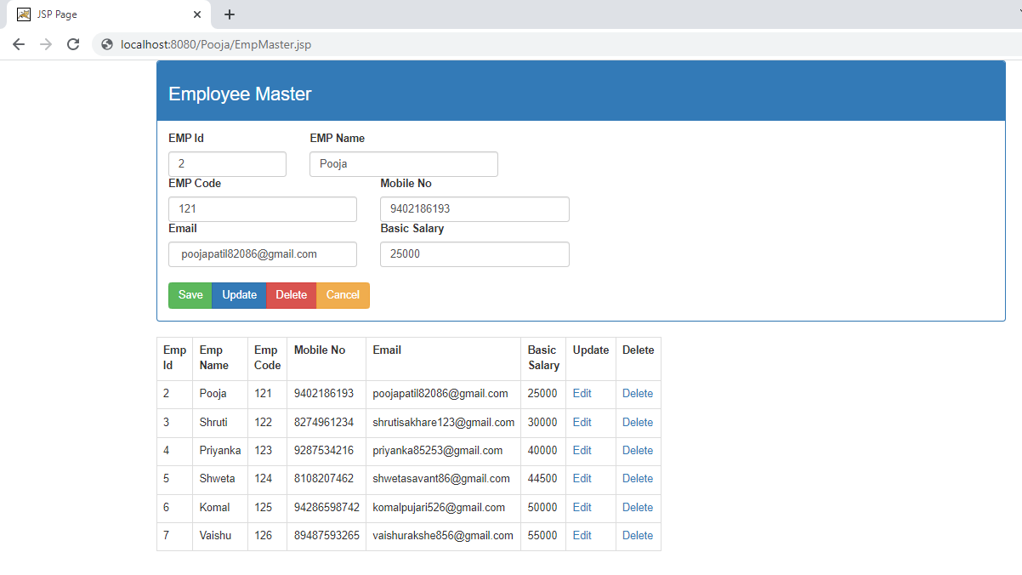

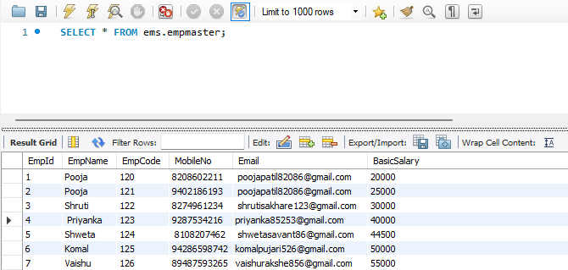

**Update Record:**

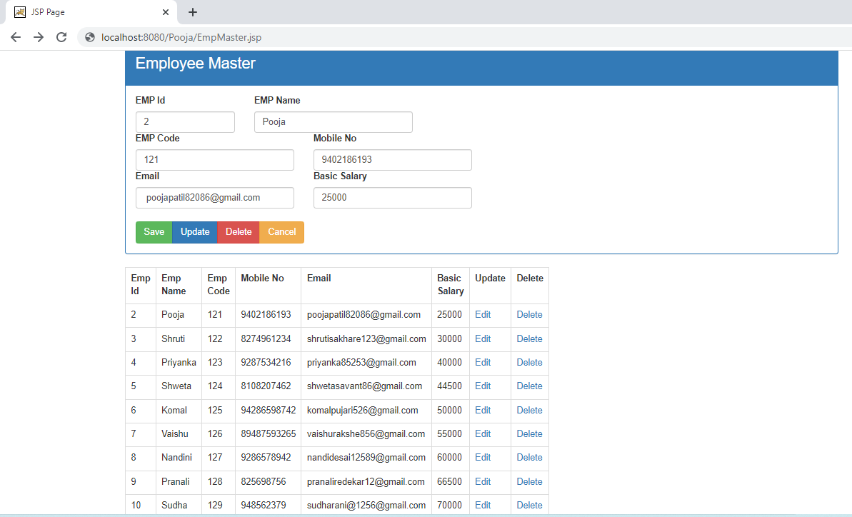

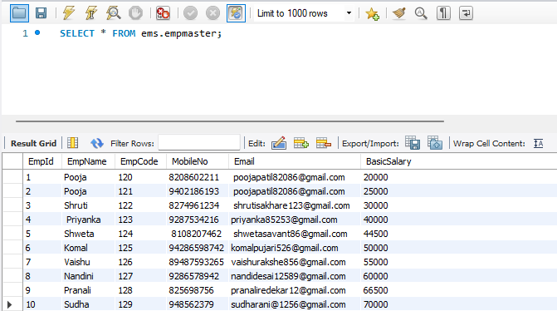

**Delete Record**:



